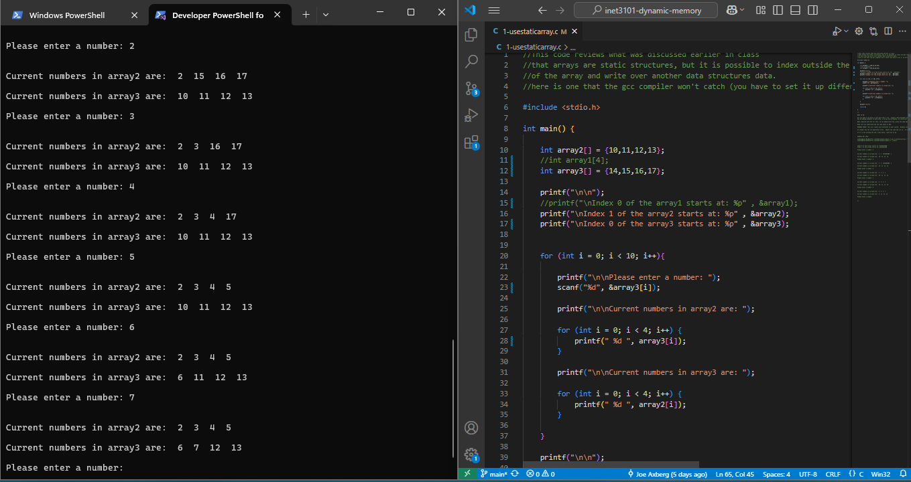

1^

N/A

2^

The original code you provided used a for loop with a fixed number of inputs. This meant that once the allocated memory was filled, the program wouldn’t allow for additional inputs. The updated code replaced the for loop with an infinite while loop. The key improvement is shown through the usage of dynamic memory reallocation using realloc(). When the array reaches capacity, it doubles in size. This solves the problem of a fixed-size allocation by allowing the program to handle an arbitrary number of inputs. The modified code also includes a stopping condition.

3^

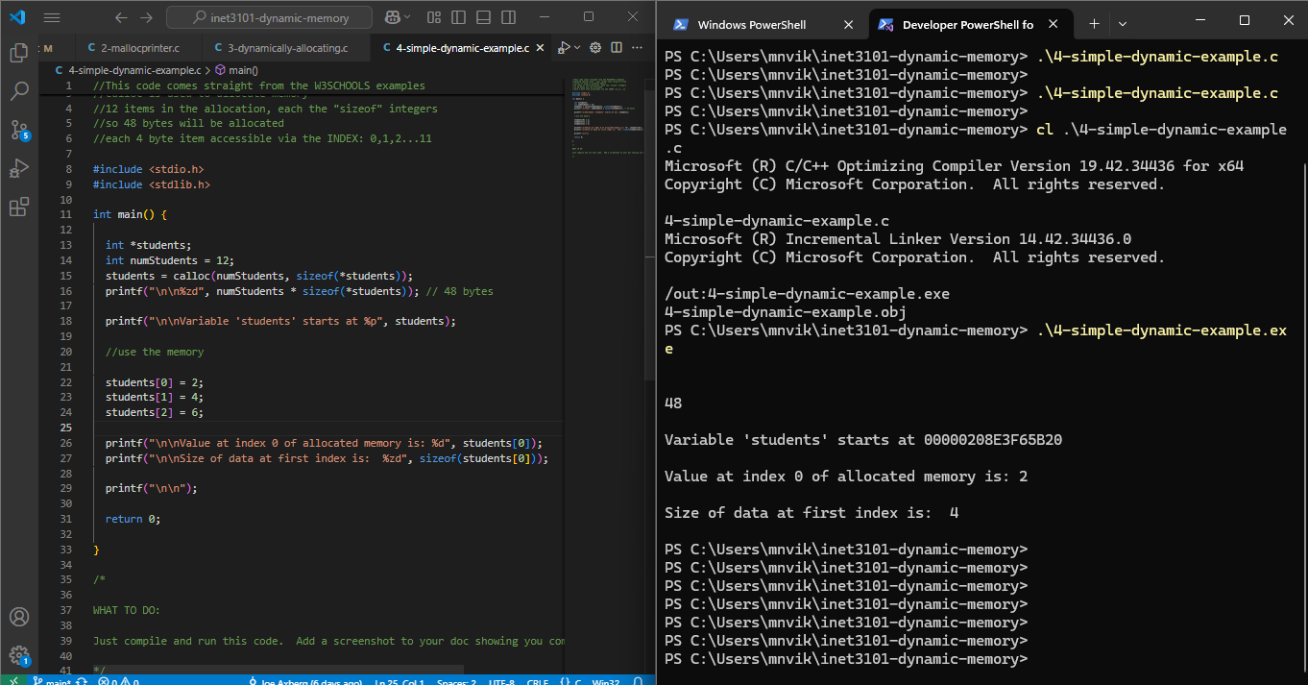

4^

When it comes to Object Oriented Porgramming, an object is noted as an instance of a class that contains both attributes and methods. Objects store information in cariablea as well as defining functions in order to manipulate data. Objects interact with other objects in order to build complex systems that are run efficiently.

5^

The usage of linked lists help to solve many problems that dynamic memory would also be used to solve as its usage provides for flexible and efficient memory management. Linked lists can dynamically allocate memory for each new node as needed which avoids the need for realloc() which an array would require. It’s more efficient as well in terms of insertions and deletions and doesnt interfere with other elements in terms of shifting. Linked lists do use more memory because of their usage of pointers but they’re better for dynamically changing data sets.

6^

N/A

7^

Not found anywhere?

8^